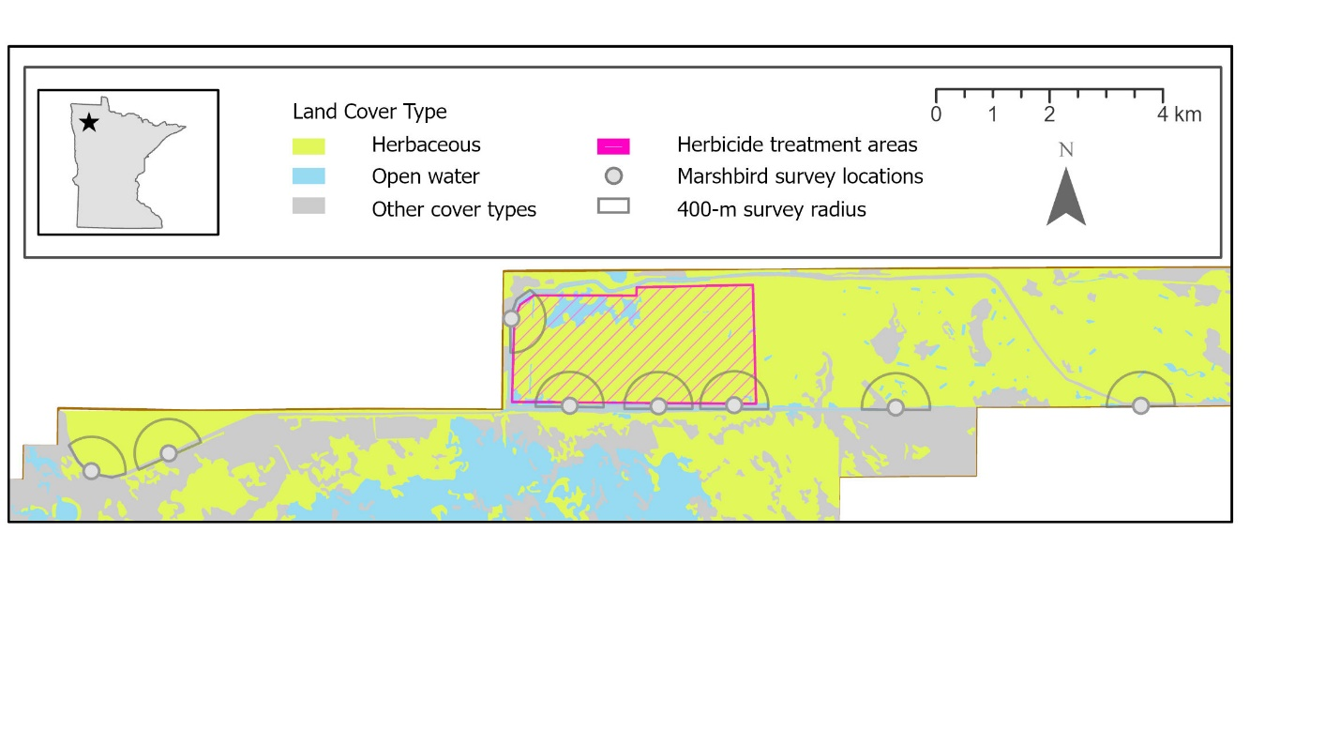

Figure 2.Map of Elm Lake Wildlife Management Area in northwestern Minnesota, USA, indicating areas that received aerial glyphosate application to control cattail (*Typha angustifolia* and *Typha* x *glauca*) in late summer and early autumn 2015, and marshbird survey locations.